**DAILY ONLINE ACTIVITIES SUMMARY**

|  |  |  |  |  |  |  |  |  |
| --- | --- | --- | --- | --- | --- | --- | --- | --- |
| **Date:** | **23-06-2020** | | | | | **Name:** | **Anusha** | |
| **Sem & Sec** | **VIII Semester & A Section** | | | | | **USN:** | **4AL16CS014** | |
| **Online Test Summary** | | | | | | | | |
| **Subject** | | **-** | | | | | | |
| **Max. Marks** | | **-** | | **Score** | | | **-** | |
| **Certification Course Summary** | | | | | | | | |
| **Course** | **Introduction to Amazon Elastic Compute Cloud (EC2)** | | | | | | | |
| **Certificate Provider** | | | **Amazon Web Service** | | **Duration** | | | **10 minutes** |
| **Coding Challenges** | | | | | | | | |
| **Problem Statement: Write a program for circular array roatation.** | | | | | | | | |
| **Status: COMPLETED** | | | | | | | | |
| **Uploaded the report in Github** | | | | | **YES** | | | |
| **If yes Repository name** | | | | | **anushasuvarna-014** | | | |
| **Uploaded the report in slack** | | | | | **YES** | | | |

Online Test Details:

NIL

Certification Course 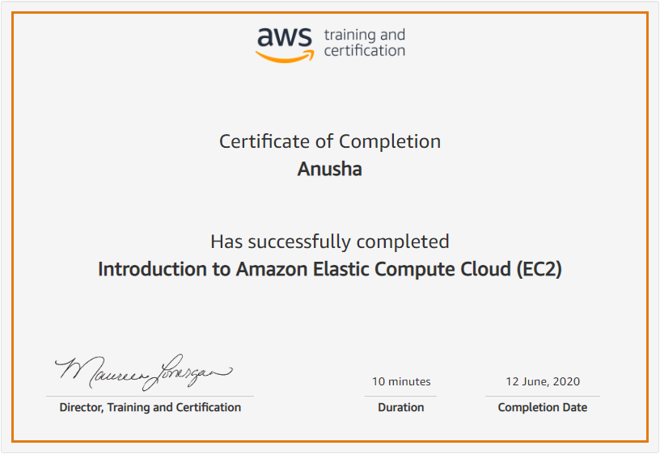

Coding Challenges Details:

**Program:**

|  |  |
| --- | --- |
|  |  |

**#include <stdio.h>**

**void rightRotate(int A[], int k, int n)**

**{**

**int aux[k];**

**for (int i = 0; i < k; i++)**

**aux[i] = A[n-k+i];**

**for (int i = n-k-1; i >= 0; i--)**

**A[i+k] = A[i];**

**for (int i = 0; i < k; i++)**

**A[i] = aux[i];**

**for (int i = 0; i < n; i++)**

**printf("%d ", A[i]);**

**printf("\n");**

**}**

**void main()**

**{**

**int A[50],k,n;**

**printf("Enter the size of array :\n");**

**scanf("%d",&n);**

**printf("Enter the array :\n");**

**for(int i=0;i<n;i++)**

**scanf("%d",&A[i]);**

**printf("Enter number of rotation :\n");**

**scanf("%d",&k);**

**rightRotate(A, k, n);**

**}**